**Maze Game:**

* **Initial State :**
  + Fire truck at Start Point (Start of maze).
* **Successor Function :**
  + Fire truck move Left, Right, Up, Down.
* **Goal Test :**
  + Fire truck arrive to house fire and avoid walls.
* **Path Cost :**
  + Each move cost 5 degree in x or y axis.

**Game Tree:**

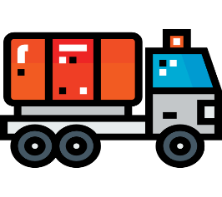

**UP**



**Left**

**Down Right**



